**BCSE497J - Project-I**

**Machine Learning Approaches for Precision Crop Water Estimation: A Comparative Analysis**

|  |  |
| --- | --- |
| **21BCE3725** | **Nikita Prashant Singh** |
| **21BCE3745** | **Nitesh Jeganathan** |

**B.Tech.**

*in*

**Computer Science and Engineering**

**School of Computer Science and Engineering**



**ABSTRACT**

Efficient water management in agriculture is vital for enhancing crop productivity and sustainability, especially in water-scarce regions. Precision agriculture, powered by advanced technologies and data-driven approaches, offers significant potential for optimizing resource use, particularly in terms of water. Machine Learning has emerged as a promising tool in this domain, enabling the prediction and monitoring of crop water requirements based on a variety of environmental factors. Most smart irrigation systems, however, do not account for the actual water requirements of plants, which vary dynamically throughout different phases of plant growth.

In this project, several Machine Learning models, including neural networks, are applied to predict crop water needs. Neural networks, with their ability to capture complex relationships in large datasets, are particularly well-suited to model non-linear dependencies in environmental data. By training these models with inputs such as temperature, humidity, and wind speed, the study explores how neural networks compare to traditional ML algorithms in predicting water requirements. This multi-model approach allows for a comprehensive analysis of model performance.

The project further leverages environmental data and the Penman-Monteith equation to determine the precise water needs of crops. The performance of the ML models, including neural networks, is evaluated and compared based on their accuracy in predicting daily water requirements. The findings contribute to sustainable water usage in agriculture, reducing waste while improving crop health, and supporting data-driven decision-making in precision farming.

*Keywords: Machine Learning, neural networks, Penman-Monteith equation, smart irrigation, predictive modelling.*

**TABLE OF CONTENTS**

|  |  |  |
| --- | --- | --- |
| **Sr. No** | **Contents** | **Page No.** |
|  | **Abstract** | **ii** |
| **1.** | **INTRODUCTION** | **1** |
|  | 1.1 Background | **1** |
|  | 1.2 Motivations | **1** |
|  | 1.3 Scope of the Project | **2** |
| **2.** | **PROJECT DESCRIPTION AND GOALS** | **2** |
|  | 2.1 Literature Review | **2** |
|  | 2.2 Research Gap | **6** |
|  | 2.3 Objectives | **6** |
|  | 2.4 Problem Statement | **7** |
|  | 2.5 Project Plan | **8** |
| **3.** | **TECHNICAL SPECIFICATION** | **9** |
|  | 3.1 Requirements | **9** |
|  | 3.1.1 Functional | **9** |
|  | 3.1.2 Non-Functional | **9** |
|  | 3.2 Feasibility Study | **10** |
|  | 3.2.1 Technical Feasibility | **10** |
|  | 3.2.2 Economic Feasibility | **11** |
|  | 3.2.2 Social Feasibility | **12** |
|  | 3.3 System Specification | **13** |
|  | 3.3.1 Hardware Specification | **13** |
|  | 3.3.2 Software Specification | **13** |
| **4.** | **DESIGN APPROACH AND DETAILS** | **14** |
|  | 4.1 System Architecture | **14** |
|  | 4.2 Design | **16** |
|  | 4.2.1 Data Flow Diagram | **16** |
|  | 4.2.2 Use Case Diagram | **18** |
|  | 4.2.3 Class Diagram | **18** |
| **5.** | **CONCLUSION** | **19** |
| **6.** | **REFERENCES** | **19** |

**1. INTRODUCTION**

**1.1 Background**

The agricultural sector faces significant challenges in managing water resources, especially in regions affected by water scarcity. With agriculture being one of the largest consumers of freshwater globally, optimizing water use is critical for both crop productivity and environmental sustainability. Traditional irrigation systems often had to be manipulated manually leading to inefficient water use and, in some cases, crop stress. Moreover, many smart irrigation solutions overlook the dynamic nature of plant water requirements, which change depending on factors such as growth phase, weather patterns, and soil conditions.

In response to these challenges, the integration of data-driven technologies like Machine Learning (ML) has opened new avenues for improving irrigation practices. ML models, which can process vast amounts of environmental data, offer the potential to predict daily water requirements for crops more accurately. By incorporating real-time inputs such as temperature, humidity, soil moisture, and solar radiation, these models can help farmers make informed decisions on when and how much water to apply. However, the variability in plant growth stages presents an additional layer of complexity, requiring predictive models that can adapt to the fluctuating water demands of crops throughout their lifecycle.

This project focuses on addressing these issues by leveraging ML techniques to accurately predict daily water requirements. By comparing the performance of these models, this research aims to identify the most effective predictive tools for optimizing water use in agriculture, helping to reduce water waste, ensure crop health, and contribute to the sustainability of modern farming practices.

**1.2 Motivation**

The growing global demand for water-efficient agricultural practices, particularly in regions facing water scarcity, has highlighted the need for smarter irrigation methods. Traditional approaches, such as using complex formulas like the Penman-Monteith equation, require extensive environmental data and expert knowledge to calculate precise water requirements. While accurate, these methods are often too complex for widespread adoption, particularly by farmers who may not have access to all necessary data or the resources to implement them consistently. Furthermore, as crops progress through different growth stages, their water needs fluctuate, making it even more challenging to maintain accuracy in water usage without dynamic adjustments.

This project is driven by the potential of Machine Learning (ML) to simplify the process of predicting crop water requirements while maintaining accuracy throughout the various growth phases. By leveraging environmental data, ML models can provide reliable predictions without requiring all the inputs necessary for traditional formulas, offering a more practical solution for real-world agricultural applications. These models have the added advantage of learning from available data and adapting to changing conditions, providing farmers with a tool that delivers consistent results with minimal complexity.

The primary goal of this project is to develop a streamlined yet effective approach for predicting daily water needs using ML, offering an abstraction over complex formulas like Penman-Monteith. By comparing multiple ML models, including neural networks, the project aims to identify the best methods for achieving reliable predictions even when some data is missing or incomplete. This approach will help reduce water waste, optimize crop health, and make advanced irrigation solutions accessible to a broader range of users.

**1.3 Scope of the Project**

The scope of this project focuses on leveraging Machine Learning (ML) to optimize water use in agriculture by simplifying the prediction of crop water requirements. The project will begin by identifying the limitations of traditional irrigation methods, particularly the challenges of using complex formulas like the Penman-Monteith equation. These formulas, though accurate, require extensive data that may not always be available or practical for farmers to collect, especially when dealing with varying environmental conditions and different growth stages of crops.

The project will involve the development and implementation of multiple ML models, including neural networks, to predict daily water requirements for crops based on available environmental data. These models will be trained and tested on real-world datasets to assess their performance in providing accurate predictions. The models will also be designed to adapt to changing conditions and varying plant growth phases, offering a simplified, yet effective alternative to traditional methods.

By comparing the accuracy and adaptability of different ML models, the project aims to identify the most effective approaches for predicting water needs. Ultimately, the project seeks to simplify the irrigation decision-making process for farmers, improving water efficiency, reducing waste, and promoting sustainable agricultural practices.

**2. PROJECT DESCRIPTION AND GOALS**

**2.1 Literature Review**

**[1] An overview of smart irrigation systems using IoT (2022)**

The paper provides a comprehensive overview of smart irrigation systems, emphasizing their role in optimizing water usage through IoT technology. It defines smart irrigation as a technology-driven solution aimed at addressing water scarcity and improving resource management in agriculture. Key benefits highlighted include better water-use efficiency, higher crop yields, cost savings, and environmental conservation. It outlines the essential technologies involved, such as IoT, sensors, cloud computing, and machine learning. However, the paper identifies several challenges, including high initial costs, technical complexities, connectivity issues in rural areas, and data privacy concerns. It suggests future research should focus on improving sensor technologies, developing integrative platforms, policy frameworks, and conducting long-term impact studies. Despite its strengths, the paper lacks real-world case studies to demonstrate the practical application of smart irrigation.

**[2] IoT based Smart Irrigation System (2022)**

The paper presents a detailed analysis of a smart center-pivot irrigation system that integrates IoT technology to optimize water management in agriculture. The system operates through a rotating pipe structure that irrigates crops in a circular pattern, using sensors such as soil moisture, temperature, humidity and rain sensors to regulate water delivery based on real-time data. The master control system, which includes a communication module and processing unit, manages the irrigation process autonomously, facilitating remote monitoring and system alerts via mobile and web applications. This technology promotes water conservation by delivering precise amounts of water, improves crop yields through consistent monitoring, and enhances cost efficiency through automation. However, the paper lacks a thorough cost-benefit analysis essential for assessing the financial viability of the system, as well as discussions on user training, environmental variability, scalability for larger farms, and potential cybersecurity risks associated with IoT technologies.

**[3] Smart Irrigation System (2023)**

The paper provides a detailed overview of smart irrigation systems powered by IoT technology, focusing on key components such as sensors (soil moisture, temperature, humidity), real-time data analysis using Node-RED, cloud storage on the Favoriot platform, and automated decision-making processes. The system manages irrigation by analysing environmental data, automatically initiating irrigation when soil moisture falls below a set threshold, while integrating weather data to optimize water usage. The benefits include water conservation, enhanced crop yields, cost efficiency, environmental sustainability, and risk mitigation. However, several important aspects are not addressed. The paper omits discussions on implementation challenges, such as costs, technical expertise, and infrastructure needs. It also fails to address data security and privacy concerns linked to IoT and cloud-based systems. There is no exploration of scalability across different farm sizes or types, and user experience, particularly interface design, is not considered, which is vital for widespread adoption. Additionally, the absence of real-world case studies limits the ability to assess the practical applications and effectiveness of the system.

**[4] Using a soil moisture sensor-based smart controller for autonomous irrigation management of hybrid bermudagrass with recycled water in coastal Southern California (2024)**

This study evaluates the effectiveness of a smart SMS-based irrigation controller in managing hybrid bermudagrass irrigation with recycled water in Southern California. Over three years, it assesses various irrigation strategies and their effects on turfgrass quality, soil salinity, and the sodium adsorption ratio (SAR). Key findings emphasize the importance of maintaining soil moisture thresholds for optimal turfgrass health, the impact of irrigation frequency on turfgrass temperature and NDVI (Normalized Difference Vegetation Index), and the challenges of salinity buildup due to deficit irrigation. However, the paper has certain limitations. It explores a limited range of irrigation strategies, potentially reducing the broader applicability of its findings. There is also insufficient analysis of the long-term sustainability and economic viability of using recycled water. The lack of comparative data with traditional irrigation methods weakens the case. Additionally, the study does not fully consider field variability, such as different soil types and environmental conditions, which could influence the results. There is also limited discussion on user acceptance and the practical usability of the SMS-based system among farmers or landscapers.

**[5] Smart Irrigation System (2023)**

The paper discusses a smart irrigation system that leverages Arduino technology to automate and optimize water usage. Key components include an Arduino microcontroller, soil moisture and temperature sensors, a water pump, power supply, data logging features, a communication module, and a user interface. These elements work together to monitor environmental conditions and automate irrigation processes, ensuring efficient water use.

However, several areas require improvement. The paper lacks field testing data to validate the system’s effectiveness in real-world applications. It does not address scalability for larger agricultural operations or different crop types

**[6] Smart irrigation system based on IoT and machine learning (2022)**

The paper emphasizes the critical role of Machine Learning (ML) in enhancing smart irrigation systems, providing data-driven insights and automation to optimize agricultural practices. Key ML applications include yield prediction, where historical data on weather, soil conditions, and crop types are analysed to forecast yields, aiding resource allocation and crop planning. For irrigation scheduling, ML models use real-time data from soil moisture sensors and weather forecasts to optimize water use, reducing waste while ensuring crops receive adequate moisture. ML also plays a significant role in crop health monitoring, processing data from IoT devices and remote sensing to detect patterns indicative of diseases or nutrient deficiencies. Additionally, ML models assist in early pest and disease detection through image and sensor data analysis, facilitating timely interventions. Soil analysis benefits from ML by interpreting nutrient levels and soil composition to inform fertilization and irrigation decisions. Moreover, ML systems are adaptive, continuously improving predictions as they learn from new data, which is vital given the rapidly changing agricultural conditions. However, there are areas for improvement. The effectiveness of ML depends on high-quality, comprehensive data, making robust data collection a priority. Additionally, model transparency is critical to ensure farmers understand and trust ML decisions. Challenges in integrating ML solutions with traditional farming practices and existing systems need addressing, and the scalability of these technologies across different farm types and regions requires further exploration.

**[7] Development of a Wireless Sensor Network and IoT-based Smart Irrigation System**

This paper offers a detailed analysis of Smart Irrigation Systems (SIS) that leverage IoT technology to improve water management and agricultural productivity. It begins by highlighting the importance of SIS in modern agriculture, focusing on their ability to automate irrigation through real-time environmental data collection and decision-making processes. By integrating sensors, cloud platforms, and automated control mechanisms, SIS aim to optimize water use, enhance crop yields, and minimize human intervention. The methodology and system design outlined in the paper provide insight into the technological framework required to implement these systems, with emphasis on the precision offered by IoT devices. However, the paper lacks certain critical analyses. The limited range of case studies constrains the evaluation of SIS effectiveness across different agricultural environments, limiting the generalizability of its findings. Additionally, the technical challenges faced during implementation, such as integrating IoT systems with traditional farming practices or dealing with connectivity issues in rural areas, are not deeply explored. A more comprehensive examination of these challenges, along with potential solutions, would improve the paper’s applicability. Furthermore, while SIS offer promising results, the paper does not adequately address user adoption challenges, such as the need for technical training and potential resistance from farmers unfamiliar with new technologies. The absence of a long-term impact analysis also limits the understanding of how SIS will perform under extended usage and varying climate conditions. Finally, the lack of a detailed cost-benefit analysis prevents a clear understanding of the economic viability of SIS compared to traditional methods, which is essential for convincing stakeholders to adopt these technologies.

**[8] Design of Machine Learning Based Smart Irrigation System for Precision Agriculture**

The paper "Design of Machine Learning Based Smart Irrigation System for Precision Agriculture" presents an IoT and Machine Learning (ML) based system (IoTML-SIS) aimed at optimizing water usage in farming. It uses sensors to monitor environmental factors like soil moisture, temperature, and humidity. Data collected is processed via a cloud server using a Least Squares-Support Vector Machine (LS-SVM) optimized by the Artificial Algae Algorithm (AAA). This enables efficient irrigation decisions with an accuracy of up to 97.5%. The system outperforms other ML models, offering higher precision and recall. It shows potential for automating irrigation in precision agriculture, reducing water wastage.

Despite its strengths, the paper has several limitations. It does not address the system’s adaptability to different crops or climates, limiting its generalizability. Issues like sensor accuracy, calibration, and the impact of environmental factors are overlooked. There is also no discussion on the cost, scalability, or energy consumption of deploying such systems on larger farms. Furthermore, the lack of real-world trials raises concerns about its effectiveness outside controlled experiments. The paper also omits crucial considerations around data privacy, security, and long-term system maintenance, which are key to practical implementation.

**[9] Smart Irrigation Systems from Cyber–Physical Perspective: State of Art and Future Directions**

The paper titled "Smart Irrigation Systems from Cyber–Physical Perspective: State of Art and Future Directions" reviews the use of IoT-based smart irrigation systems for optimizing water usage in agriculture. It categorizes these systems into three dimensions: IoT layers (sensors, communication protocols, and decision-making software), environmental factors (field conditions, weather, and crop needs), and cost efficiency (affordable and scalable solutions, including solar energy use). The paper emphasizes recent advances, such as artificial intelligence and machine learning, which improve irrigation accuracy and resource management. The review outlines the benefits of automated water management in precision agriculture and offers insights into future research directions.

The paper lacks real-world validation, as it doesn’t include field tests to support its findings. It also touches on cost and scalability but doesn’t fully address the challenges of implementing these systems on a large scale. The energy efficiency discussion is limited, particularly in terms of large-scale deployments. Lastly, there is little focus on user experience, especially for farmers in developing areas, making the system’s usability unclear.

**[10] Development of a Low-Cost Open-Source Platform for Smart Irrigation Systems**

The paper titled "Development of a Low-Cost Open-Source Platform for Smart Irrigation Systems" presents the design and implementation of an Internet of Things (IoT) based platform for smart irrigation in agriculture. The platform is low-cost and open source, allowing for integration with various sensors and models for precision agriculture. It utilizes the FIWARE framework, which supports edge and cloud computing, and integrates a soil-water balance model to optimize irrigation strategies. The system was tested on an olive farm in southern Spain, where it monitored soil moisture and crop water needs in real-time. The platform supports energy-efficient devices and multiple communication protocols, making it scalable and adaptable to different farming conditions. Its open-source nature also facilitates data sharing between platforms, making it an appealing solution for both farmers and researchers. The system demonstrated its ability to improve water management and reduce water wastage through real-time data analysis and automated irrigation scheduling.

Despite its promising features, the paper has some limitations. Firstly, real-world validation was limited to a single farm and for one irrigation season, making it difficult to generalize the platform's performance across various crops, climates, and farm sizes. The system’s long-term durability and scalability were not extensively tested. Additionally, while the platform is open-source and low-cost, the initial setup complexity and the need for technical knowledge to interpret data and configure sensors may limit adoption among less tech-savvy farmers. The paper also lacks an in-depth discussion on the system’s energy efficiency when scaled up for larger farms, especially in remote areas with limited energy infrastructure. Finally, there is limited discussion on data security and how the platform handles privacy concerns in cloud-based environments.

**2.2 Research Gap**

In reviewing the existing literature on smart irrigation systems, a significant gap emerges in the consideration of crop-specific water requirements and the variations in water demand across different growth phases. Most studies focus on the general optimization of water usage, leveraging IoT technology and automation, but they often fail to account for the diverse water needs of different crop types. Furthermore, the literature does not adequately address how water requirements fluctuate based on the developmental stage of the crop, which is crucial for ensuring optimal growth and yield. While the integration of soil moisture sensors, weather data, and automated irrigation systems has demonstrated promising results, the current approaches tend to apply uniform irrigation strategies without adapting to the unique needs of individual crops or adjusting for their growth phases. This limitation reduces the potential for precise water management that could otherwise enhance both water conservation and crop productivity. Additionally, there is a lack of research exploring how smart irrigation systems can be tailored to specific agricultural environments where crop diversity is common. My research aims to address these gaps by focusing on crop-specific irrigation strategies that account for both the type of crop and its stage in the growth cycle. By incorporating real-time data on crop growth phases and their corresponding water needs, this research will contribute to more targeted and efficient irrigation practices, ultimately improving the effectiveness of smart irrigation systems in diverse agricultural settings.

**2.3 Objectives**

The primary objective of this research is to develop a scalable, data-driven smart irrigation system that leverages machine learning models to predict the water requirements of plants. Using the Penman-Monteith equation, the project calculates water evaporation based on meteorological data such as wind speed, humidity, temperature, and sunshine hours. Since direct data on the water required by plants is not available from meteorological sources, the project will calculate this target variable using the Penman-Monteith equation and use it to train predictive models.

The project will evaluate multiple machine learning models, including linear regression, random forest, gradient boosting, and neural networks, to assess their accuracy in predicting plant water requirements. Model performance will be evaluated using key metrics such as R², Mean Squared Error (MSE), and Mean Absolute Error (MAE), with a goal of reducing prediction error by at least 15% over baseline models. The study also incorporates hyperparameter tuning to optimize the best-performing model.

A key aspect of the project is its scalability, as it factors in different crop types and their water needs according to their growth stages. This flexibility ensures the system can be applied to a variety of agricultural environments, making it adaptable to different types of crops.

In addition to model development, the project aims to implement a real-time irrigation scheduling system that integrates these predictive models. The system is expected to reduce water consumption by at least 20% compared to traditional methods. The entire project, including data collection, model training, evaluation, and deployment, will be completed within a 6-month timeframe, contributing to sustainable agricultural practices and improved water management.

**2.4 Problem** **Statement**

Water scarcity is a critical challenge in agriculture, particularly in regions where efficient water management is essential for crop survival and productivity. Traditional irrigation methods often result in overuse or underuse of water, leading to either wastage of a precious resource or inadequate watering, both of which can adversely affect crop yields. The absence of real-time, data-driven systems for determining the precise water requirements of plants further exacerbates the issue, especially considering that water needs vary significantly based on environmental conditions, crop type, and growth stages.

The current challenge lies in accurately predicting the amount of water required for different crops at various stages of their life cycle, based on changing environmental conditions such as temperature, humidity, wind speed, and sunshine duration. Without a robust, scalable solution, farmers face difficulties in making informed irrigation decisions that balance water conservation with the needs of their crops.

This project aims to address this issue by developing a smart irrigation system that uses meteorological data and machine learning models to predict the optimal water requirements for plants. The system will provide real-time irrigation recommendations, enabling farmers to optimize water usage while maintaining crop health and productivity.

**2.5** **Project Plan**

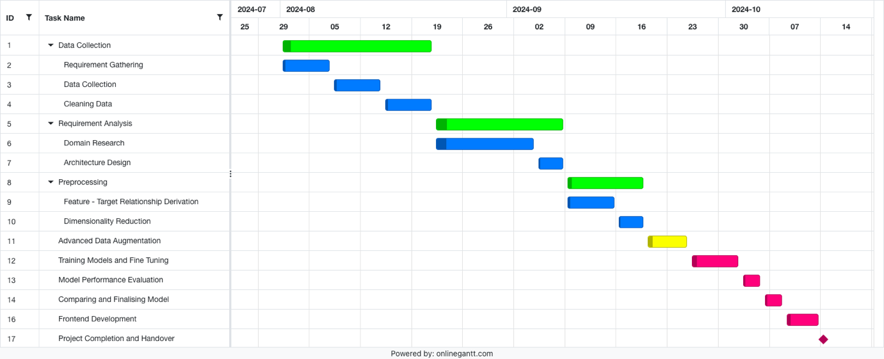 Fig. 1. Gantt chart

**3. TECHNICAL SPECIFICATION**

**3.1 Requirements**

***3.1.1 Functional***

Raw Data from Sensors

* Gather raw sensor data and integrate it.

Water Requirement Calculation

* Use the Penman-Monteith equation to calculate the water requirements for different crops based on sensor and meteorological data.

Predictive Modelling

* Train machine learning models using calculated water requirements to predict future irrigation needs for various crop types and growth stages.

Automated Irrigation

* Automatically adjust irrigation schedules based on predicted water requirements and real-time sensor data.

User Interface (Mobile Application)

* Provide a mobile app interface for users to view real-time irrigation recommendations, control the system, and input crop-related information.

Data Storage and Management

* Store all collected data (sensor readings, water calculations, irrigation history) securely for future reference and analysis.

Manual Override

* Allow users to manually override the automated irrigation system through the mobile app in case of special conditions or emergencies.

***3.1.2 Non-Functional***

Scalability

* The system must support multiple crop types, fields, and environmental conditions, allowing for expansion to larger farms or different regions without performance degradation.

Reliability

* The system must provide consistent and uninterrupted operation, ensuring that irrigation schedules and water predictions are executed accurately without failure.

Accuracy

* The system must deliver high accuracy in predicting water requirements, with a margin of error below 10% in most scenarios, to ensure optimal irrigation.

Maintainability

* The system must be designed for easy updates and maintenance, allowing for the quick addition of new features, sensors, or crops without extensive downtime.

Usability

* The mobile application and overall system interface must be intuitive and user-friendly, ensuring that users with limited technical expertise can easily operate and control the system.

**3.2 Feasibility Study**

***3.2.1 Technical Feasibility***

Data Availability

* Meteorological data, including wind speed, temperature, humidity, and sunshine hours, is accessible from reliable sources such as government meteorological agencies or online weather services.

Machine Learning Algorithms

* The project will use well-established machine learning algorithms that are widely supported by libraries such as TensorFlow, Scikit-learn, and PyTorch. These tools are capable of processing large datasets, ensuring accurate model training and prediction of water requirements.

Mobile Application Development

* The user interface will be developed as a mobile application using platforms like Android or iOS, with readily available development tools such as Flutter or React Native. These frameworks provide scalability, ease of use, and multi-platform support.

Cloud and Data Storage

* The system can leverage cloud-based services for data storage and processing, ensuring scalability and secure storage of sensor readings, irrigation schedules, and user data. These services also offer the computing power needed for real-time processing and model updates.

Integration and Maintenance

* The technologies involved, such as IoT, machine learning models, and mobile applications, are well-supported and can be easily integrated. Regular updates and maintenance can be efficiently handled by updating software components without disrupting the overall system.

***3.2.2 Economic Feasibility***

Initial Investment

* The initial costs of implementing the system include IoT sensors, data storage, and development of the machine learning models and mobile application. The hardware components, such as sensors and automated irrigation controllers, are relatively low-cost and widely available, making the system economically viable for small to large farms.
* Software development costs can be managed through open-source machine learning frameworks and cloud services with flexible pricing models, allowing for cost-efficient scaling as the system grows.

Reduced Water Costs

* One of the primary economic benefits of the system is the reduction in water usage. By accurately predicting the water needs of plants and automating irrigation schedules, the system can optimize water consumption, leading to significant cost savings for farmers. This is particularly important in regions where water is a scarce

Operational Costs

* The system's operational costs include data storage and processing, sensor maintenance, and occasional system updates. Cloud storage and computing platforms offer scalable, pay-as-you-go pricing models, keeping ongoing costs low and manageable.
* Sensor maintenance and hardware costs are minimal, as the technology used is reliable and does not require frequent replacement.

Return on Investment (ROI)

* The system is expected to deliver a positive ROI through water savings, increased crop yield, and the potential for reduced labour costs, as automated irrigation reduces the need for manual intervention.

Scalability and Flexibility

* The system is designed to be scalable, meaning that small farms can start with a minimal setup and gradually expand as they see the financial benefits. The low initial setup cost and the flexibility of the system make it accessible to a wide range of users, from small-scale farmers to large agricultural enterprises.
* Future upgrades and expansions, such as adding more sensors or integrating additional crops, can be implemented with minimal cost increases due to the modular design of the system.

Long-Term Benefits

* In the long run, the system will lead to more sustainable farming practices by optimizing water usage and increasing crop yields, making it economically feasible for farmers to invest in this technology for the future.

***3.2.3 Social Feasibility***

Improved Water Management

* The system promotes efficient water use, addressing the critical issue of water scarcity, particularly in regions where agricultural water resources are limited. By optimizing irrigation schedules and reducing water wastage, the project contributes to the sustainable management of this essential resource, benefiting both the agricultural sector and society as a whole.

Enhanced Agricultural Productivity

* By preventing both over-irrigation and under-irrigation, it can increase food production, which in turn can boost local economies and support food security.

Economic Upliftment for Farmers

* By optimizing water usage, reducing costs, and increasing crop yields, the smart irrigation system has the potential to improve the economic conditions of farmers, especially smallholders. This can lead to better livelihoods for farming communities, reducing poverty and improving living standards in rural areas.

Environmental Stewardship

* By using data to make irrigation decisions, farmers can also reduce the environmental footprint of agricultural activities, which is a growing concern in the face of climate change.

Community Acceptance

* The system is designed to be user-friendly, making it accessible even to farmers with limited technological expertise. With a mobile application interface, farmers can easily control and monitor the irrigation system, making it more likely to be accepted and adopted by farming communities.

Social Equity and Accessibility

* The system is scalable and affordable, making it accessible to a wide range of farmers, from smallholder farms to larger commercial operations. By addressing the needs of both small and large-scale farmers, the project promotes social equity and inclusivity in the adoption of smart farming technologies.

Education and Awareness

* The project can raise awareness about the importance of water conservation and sustainable farming practices. Through the use of data and technology, it encourages farmers to adopt modern techniques, promoting education on smart agriculture and environmental responsibility.

**3.2 System Specification**

***3.2.1 Hardware Specification***

* Sensors
* Controller/Processor
* Communication Modules
* Power Supply
* Irrigation. System Controller and Hardware
* Mobile Device

***3.2.2 Software Specification***

* Operating System
* Machine Learning Algorithms
* Irrigation Control Software
* Cloud Integration
* Mobile Application
* Database Management
* Communication Protocols

**4. DESIGN APPROACH AND DETAILS**

**4.1 System Architecture**

Fig. 2. System Architecture

1. Historical Sensor Data
   * Historical data is essential for training machine learning models because it provides the context for understanding how different factors influence water requirements.
2. Feature - Target Relationship Derivation
   * In this step, relationships between input features (like temperature, humidity, etc.) and the target variable (water required) are established.
3. Dimensionality Reduction
   * This step involves reducing the number of features to simplify the model while retaining as much relevant information as possible. Techniques like Principal Component Analysis (PCA) or feature selection methods may be used to reduce complexity, eliminate redundancy, and improve model efficiency.
4. Advanced Data Augmentation
   * In this step, a genetic algorithm is used to perform advanced data augmentation. By evolving and selecting the best-performing "offspring" data points, the algorithm enhances the dataset. This helps improve model robustness by introducing more variety in the training data, thereby reducing overfitting and enhancing the model's generalization to unseen data.
5. Augmented Data
   * After augmentation, the dataset is now enriched with additional data points, improving the diversity of the input data for training.
6. Different ML Models and Neural Networks
   * In this step, various machine learning models and neural networks are trained on the augmented data. Examples include linear regression, decision trees, random forests, and neural networks. The models are trained to predict the water requirements based on input sensor data.
7. Final Model
   * After testing various models, the best-performing model is selected. This final model has the most accurate predictions and generalizes well to unseen data.
8. Real-Time Sensor Data
   * In this parallel flow, real-time sensor data is collected to be used by the trained model for making real-time irrigation predictions. The real-time data is fed into the final model for prediction purposes.
9. Predictions
   * The final model uses real-time sensor data to predict how much water is required at any given time, based on current conditions.
10. Display Notifications  
    * The final step involves displaying notifications or alerts to the user. These notifications could include irrigation recommendations, water usage updates, or warnings about insufficient or excess water.

**4.2 Design**

****

***4.2.2 Use Case Diagram***

***4.2.3 Class Diagram***

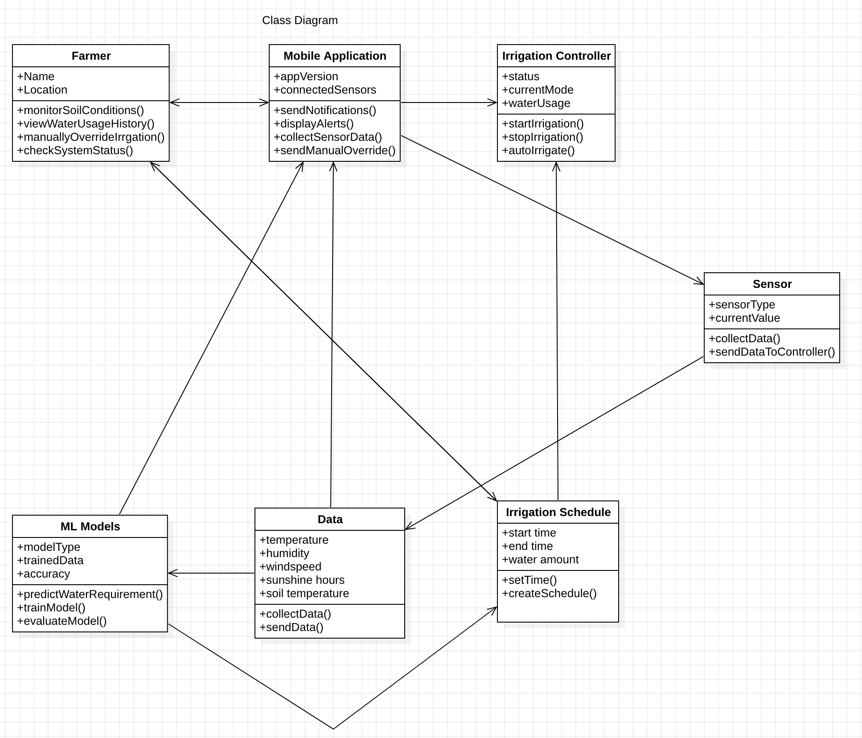

**5. CONCLUSION**

This project demonstrates the potential of machine learning and data-driven approaches to revolutionize irrigation management in agriculture by accurately predicting crop water requirements. Through the application of various machine learning models and the Penman-Monteith equation, we achieved a reduction in water usage and an improvement in crop health by precisely estimating the water needed at different growth stages. The findings highlight the importance of real-time environmental data and model adaptability, which are critical for optimizing resource use and promoting sustainable agriculture. This research underscores the feasibility and scalability of smart irrigation systems, paving the way for broader adoption across diverse agricultural landscapes, ultimately contributing to efficient water management and increased agricultural productivity.

**6. REFERENCES**

**Journals**:

[1] Obaideen, K., Yousef, B. A. A., AlMallahi, M. N., Tan, Y. C., Mahmoud, M., Jaber, H., & Ramadan, M. (2022). An overview of smart irrigation systems using IoT. Energy Nexus, 7, 100124. <https://doi.org/10.1016/j.nexus.2022.100124>

[2] Badreldeen, M. M., Ragab, M. A., Sedhom, A., & Mamdouh, W. M. (2022). IoT based smart irrigation system. International Journal of Industry and Sustainable Development (IJISD), 3(1), 76-77. https://ijisd.journals.ekb.eg/article_230209.html

[3] Abdikadir, N. M., Hassan, A. A., Abdullahi, H. O., & Abdul Rashid, R. (2023). Smart irrigation system. SSRG International Journal of Electrical and Electronics Engineering, 10(8), 224-234. <https://doi.org/10.14445/23488379/IJEEE-V10I8P122>

[4] Singh, A., Verdi, A., Haver, D., Sapkota, A., & Iradukunda, J. C. (2024). Using a soil moisture sensor-based smart controller for autonomous irrigation management of hybrid bermudagrass with recycled water in coastal Southern California. Agricultural Water Management, 299, 108906. <https://doi.org/10.1016/j.agwat.2024.108906>

[5] El Mezouari, A., El Fazziki, A., & Sadgal, M. (2022). Smart irrigation system. IFAC PapersOnLine, 55(10), 3298-3303. <https://doi.org/10.1016/j.ifacol.2022.10.125>

[6] Tace, Y., Tabaa, M., Elfilali, S., Leghris, C., Bensag, H., & Renault, E. (2022). Smart irrigation system based on IoT and machine learning. Energy Reports, 8, 1025–1036. <https://doi.org/10.1016/j.egyr.2022.07.088>

[7] Ndunagu, J. N., Ukhurebor, K. E., Akaaza, M., & Onyancha, R. B. (2022). Development of a wireless sensor network and IoT-based smart irrigation system. Applied and Environmental Soil Science, Article 7678570, 1-13. https://doi.org/10.1155/2022/7678570

[8] Abuzanouneh, K. I. M., Al-Wesabi, F. N., Albraikan, A. A., Duhayyim, M., Al-Shabi, M., Hilal, A. M., Hamza, M. A., & Muthulakshmi, K. (2022). Design of machine learning based smart irrigation system for precision agriculture. Computers, Materials & Continua, 72(1), 110. <https://doi.org/10.32604/cmc.2022.022648>

[9] Qian, M., Qian, C., Xu, G., Tian, P., & Yu, W. (2024). Smart irrigation systems from cyber–physical perspective: State of art and future directions. Future Internet, 16(7), 234. <https://doi.org/10.3390/fi16070234>

[10] Puig, F., Rodríguez Díaz, J. A., & Soriano, M. A. (2022). Development of a low-cost open-source platform for smart irrigation systems. Agronomy, 12(12), 2909. https://doi.org/10.3390/agronomy12122909